**CHAPTER 3 MALICIOUS CODE**

Malware comes in many forms, from ransomware and remote access Trojans to Trojans, bots, and the command-and-control infrastructures that allow attackers to run entire networks of compromised systems.

In this chapter, you will explore the various types of malware, as well as the distinguishing elements, behaviors, and traits of each malware type. You will learn about the indicators that you should look for, the response methods that organizations use to deal with each type of malware, as well as controls that can help protect against them.

Finally, you will explore attacks against the protective technologies and systems that are put in place to prevent malware attacks. You will learn about the concept of adversarial artificial intelligence, attacks against machine learning (ML) systems, and how ML algorithms can be protected against adversarial attacks.

**MALWARE**

The term malware describes a wide range of software that is intentionally designed to cause harm to systems and devices, networks, or users. Malware can also gather information, provide illicit access, and take a broad range of actions that the legitimate owner of a system or network may not want to occur. The SY0-601 Security+ exam objectives include a number of the most common types of malware, and you will need to be familiar with each of them, how to tell them apart, how you can identify them, and common techniques used in combatting them.

Domain 1.0, Threats, Attacks, and Vulnerabilities of the SY0-601 exam objectives introduces many types of malware and asks you to analyze potential indicators to determine the type of attack. When you tackle malware-based questions, you will need to know the distinctive characteristics of each type of malware and what might help you tell them apart. For example, a Trojan is disguised as legitimate software, whereas ransomware will be aimed at getting payment from a victim. As you read this section, remember to pay attention to the differences between each type of malware and how you would answer questions about them on the exam!

**RANSOMWARE**

Ransomware is malware that takes over a computer and then demands a ransom. There are many types of ransomware, including crypto malware, which encrypts files and then holds them hostage until a ransom is paid. Other ransomware techniques include threatening to report the user to law enforcement due to pirated software or pornography, or threatening to expose sensitive information or pictures from the victim's hard drive or device.

One of the most important defenses against ransomware is an effective backup system that stores files in a separate location that will not be impacted if the system or device it backs up is infected and encrypted by ransomware. Organizations that are preparing to deal with ransomware need to determine what their response will be; in some cases, paying ransoms has resulted in files being returned, and in others attackers merely demanded more money.

Some ransomware has been defeated, and defenders may be able to use a preexisting decryption tool to restore files. Antivirus and antimalware providers as well as others in the security community provide anti-ransomware tools.

**TROJANS**

Trojans, or Trojan horses, are a type of malware that is typically disguised as legitimate software. They are called Trojan horses because they rely on unsuspecting individuals running them, thus providing attackers with a path into a system or device. Remote access Trojans (RATs) provide attackers with remote access to systems. Some legitimate remote access tools are used as RATs, which can make identifying whether a tool is a legitimate remote support tool or a tool being used for remote access by an attacker difficult. Antimalware tools may also cause false positives when they find remote access tools that may be used as RATs, but disabling this detection can then result in RATs not being detected. Security practitioners often combat Trojans and RATs using a combination of security awareness—to encourage users to not download untrusted software—and antimalware tools that detect Trojan and RAT-like behavior and known malicious files.

The Security+ Exam Outline calls out remote access Trojans (RATs) and Trojans separately. RATs are a subset of Trojans, so not every Trojan is a RAT. Make sure you remember that RATs provide remote access and monitoring of a system for attackers.

**WORMS**

Unlike Trojans that require user interaction, worms spread themselves. Although worms are often associated with spreading via attacks on vulnerable services, any type of spread through automated means is possible, meaning that worms can spread via email attachments, network file shares, or other methods as well. Worms also self-install, rather than requiring users to click on them, making them quite dangerous.

**STUXNET: NATION-STATE-LEVEL WORM ATTACKS**

The 2010 Stuxnet attack is generally recognized as the first implementation of a worm as a cyber weapon. The worm was aimed at the Iranian nuclear program and copied itself to thumb drives to bypass air-gapped (physically separated systems without a network connection) computers. Stuxnet took advantage of a number of advanced techniques for its time, including using a trusted digital certificate, searching for specific industrial control systems that were known to be used by the Iranian nuclear program, and specific programming to attack and damage centrifuges while providing false monitoring data to controllers to ensure that the damage would not be noticed until it was too late.

You can read about Stuxnet in more depth at www.wired.com/2014/11/countdown-to-zero-day-stuxnet and spectrum.ieee.org/telecom/security/the-real-story-of-stuxnet.

**ROOTKITS**

Rootkits are malware that is specifically designed to allow attackers to access a system through a backdoor. Many modern rootkits also include capabilities that work to conceal the rootkit from detection through any of a variety of techniques, ranging from leveraging filesystem drivers to ensure that users cannot see the rootkit files, to infecting startup code in the master boot record (MBR) of a disk, thus allowing attacks against full-disk encryption systems.

Rootkit detection can be challenging, because a system infected with malware like this cannot be trusted. That means that the best way to detect a rootkit is to test the suspected system from a trusted system or device. In cases where that isn't possible, rootkit detection tools look for behaviors and signatures that are typical of rootkits. Techniques like integrity checking and data validation against expected responses can also be useful for rootkit detection, and anti-rootkit tools often use a combination of these techniques to detect complex rootkits.  
Once a rootkit is discovered, removal can be challenging. Although some antimalware and anti-rootkit tools are able to remove specific rootkits, the most common recommendation whenever possible is to rebuild the system or to restore it from a known good backup. As virtual machines, containers, system imaging, and software-defined environments have become more common, they have simplified restoration processes, and in many cases may be as fast, or faster, than ensuring that a system infected with a rootkit has been properly and fully cleaned.

Like many of the malware types you will read about here, the best ways to prevent rootkits are normal security practices, including patching, using secure configurations, and ensuring that privilege management is used. Tools like secure boot and techniques that can validate live systems and files can also be used to help prevent rootkits from being successfully installed or remaining resident.

**BACKDOORS**

Backdoors are methods or tools that provide access that bypasses normal authentication and authorization procedures, allowing attackers access to systems, devices, or applications. Backdoors can be hardware or software based, but in most scenarios for the Security+ exam you will be concerned with software-based backdoors.

As with many of the malware types we discuss here, a malware infection may include multiple types of malware tools. In fact, Trojans and rootkits often include a backdoor so that attackers can access the systems that they have infected.

Much like rootkits, backdoors are sometimes used by software and hardware manufacturers to provide ongoing access to systems and software. Manufacturer-installed backdoors are a concern since they may not be disclosed, and if they are discovered by attackers, they can provide access that you may not be aware of.

Detecting backdoors can sometimes be done by checking for unexpected open ports and services, but more complex backdoor tools may leverage existing services. Examples include web-based backdoors that require a different URL under the existing web service, and backdoors that conceal their traffic by tunneling out to a remote control host using encrypted or obfuscated channels.

**BOTS**

Bots are remotely controlled systems or devices that have a malware infection. Groups of bots are known as botnets, and botnets are used by attackers who control them to perform various actions, ranging from additional compromises and infection, to denial-of-service attacks or acting as spam relays. Large botnets may have hundreds of thousands of bots involved in them, and some have had millions of bots in total.

Many botnet command and control (C&C) systems operate in a client-server mode, as shown in Figure 3.1. In this model, they will contact central control systems, which provide commands and updates, and track how many systems are in the botnet. Internet Relay Chat (IRC) was frequently used to manage client-server botnets in the past, but many modern botnets rely on secure HTTP (HTTPS) traffic to help hide C&C traffic and to prevent it from easily being monitored and analyzed by defenders.

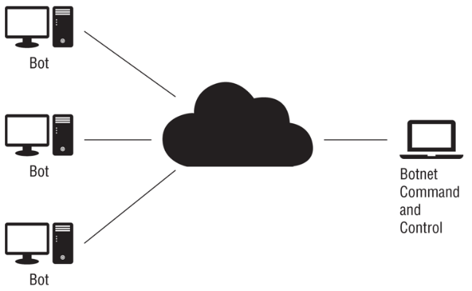

FIGURE 3.1 Client-server botnet control model

In addition to client-server botnets, peer-to-peer botnet control models, shown in Figure 3.2, are frequently used. Peer-to-peer networks connect bots to each other, making it harder to take down a single central server or a handful of known C&C IP addresses or domains. Encrypted peer-to-peer traffic can be exceptionally difficult to identify, although ML tools that monitor network traffic for behavior-based patterns as well as large, multiorganization datasets can help.

  
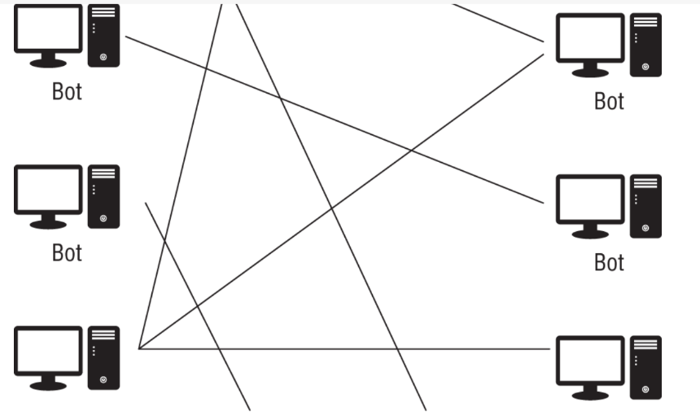

**FIGURE 3.2 Peer-to-peer botnet control model**

Many botnets use fast flux DNS, which uses many IP addresses that are used to answer queries for one or more fully qualified DNS names. Frequent updates (fast flux) mean that the many systems in the network of control hosts register and de-register their addresses, often every few minutes on an ongoing basis. More advanced techniques also perform similar rapid changes to the DNS server for the DNS zone, making it harder to take the network down. Techniques like that can be defeated in controlled networks by forcing DNS requests to organizationally controlled DNS servers rather than allowing outbound DNS requests. Logging all DNS requests can also provide useful information when malware hunting, because machine-generated DNS entries can frequently be easily spotted in logs. Although IRC was commonly used for botnet control, newer botnets often use fast flux DNS and encrypted C&C channels disguised as otherwise innocuous-seeming web, DNS, or other traffic.

Detecting botnets is often accomplished by analysis of bot traffic using network monitoring tools like IPSs and IDSs and other network traffic analysis systems. Additional data is gathered through reverse engineering and analysis of malware infections associated with the bot. The underlying malware can be detected using antivirus and antimalware tools, as well as tools like endpoint detection and response tools.

**BOTNETS AND DISTRIBUTED DENIAL-OF-SERVICE (DDOS) ATTACKS**

Botnets can be used to attack services and applications, and distributed denial-of-service (DDoS) attacks against applications are one common application of botnets. Botnets rely on a combination of their size, which can overwhelm applications and services, and the number of systems that are in them, which makes it nearly impossible to identify which hosts are maliciously consuming resources or sending legitimate-appearing traffic with a malicious intent.

Identifying a botnet-driven DDoS attack requires monitoring network traffic, trends, and sometimes upstream visibility from an Internet service provider. The symptoms can be difficult to identify from a significant increase in legitimate traffic, meaning that security tools like security information and event management (SIEM) systems that can correlate data from multiple sources may be required. Behavior analysis tools can also help differentiate a DDoS from more typical traffic patterns.

**KEYLOGGERS**

Keyloggers are programs that capture keystrokes from keyboards, although keylogger applications may also capture other input like mouse movement, touchscreen inputs, or credit card swipes from attached devices. Keyloggers work in a multitude of ways, ranging from tools that capture data from the kernel, to APIs or scripts, or even directly from memory. Regardless of how they capture data, the goal of a keylogger is to capture user input to be analyzed and used by an attacker.

Preventing software keylogging typically focuses on normal security best practices to ensure that malware containing a keylogger is not installed, including patching and systems management, as well as use of antimalware tools. Since many keyloggers are aimed at acquiring passwords, use of multifactor authentication (MFA) can help limit the impact of a keylogger, even if it cannot defeat the keylogger itself.

In more complex security environments where underlying systems cannot be trusted, use of bootable USB drives can prevent use of a potentially compromised underlying operating system.

**LOGIC BOMBS**

Logic bombs, unlike the other types of malware described here, are not independent malicious programs. Instead, they are functions or code that are placed inside other programs that will activate when set conditions are met. Some malware uses this type of code to activate when a specific date or set of conditions is met. Though relatively rare compared to other types of malware, logic bombs are a consideration in software development and systems management, and they can have a significant impact if they successfully activate.

**VIRUSES**

Computer viruses are malicious programs that self-copy and self-replicate. Viruses require one or more infection mechanisms that they use to spread themselves, typically paired with some form of search capability to find new places to spread to. Viruses also typically have both a trigger, which sets the conditions for when the virus will execute, and a payload, which is what the virus does, delivers, or the actions it performs. Viruses come in many varieties, including

* Memory-resident viruses, which remain in memory while the system of device is running
* Non-memory-resident viruses, which execute, spread, and then shut down
* Boot sector viruses, which reside inside the boot sector of a drive or storage media
* Macro viruses, which use macros or code inside word processing software or other tools to spread
* Email viruses, which spread via email either as attachments or as part of the email itself using flaws within email clients

**FILELESS VIRUSES**

Fileless virus attacks are similar to traditional viruses in a number of critical ways. They spread via methods like spam email and malicious websites, and they exploit flaws in browser plug-ins and web browsers themselves. Once they successfully find a way into a system, they inject themselves into memory and conduct further malicious activity, including adding the ability to reinfect the system by the same process at reboot through a registry entry or other technique. At no point do they require local file storage, because they remain memory resident throughout their entire active life—in fact, the only stored artifact of many fileless attacks would be the artifacts of their persistence techniques, like the registry entry shown in Figure 3.3.

**FIGURE 3.3 Fileless virus attack chain**

As you might expect from the infection flow diagram in Figure 3.3, fileless attacks require a vulnerability to succeed, so ensuring that browsers, plug-ins, and other software that might be exploited by attackers are up to date and protected can prevent most attacks. Using antimalware tools that can detect unexpected behavior from scripting tools like PowerShell can also help stop fileless viruses. Finally, network-level defenses like IPSs, as well as reputation-based protection systems, can prevent potentially vulnerable systems from browsing known malicious sites.

**SPYWARE**

Spyware is malware that is designed to obtain information about an individual, organization, or system. Various types of spyware exist, with different types of information targeted by each. Many spyware packages track users' browsing habits, installed software, or similar information and report it back to central servers. Some spyware is relatively innocuous, but malicious spyware exists that targets sensitive data, allows remote access to web cameras, or otherwise provides illicit or undesirable access to the systems it is installed on. Spyware is associated with identity theft and fraud, advertising and redirection of traffic, digital rights management (DRM) monitoring, and with stalkerware, a type of spyware used to illicitly monitor partners in relationships.

Spyware is most frequently combated using antimalware tools, although user awareness can help prevent the installation of spyware that is included in installers for software (thus acting as a form of Trojan), or through other means where spyware may appear to be a useful tool or innocuous utility.

**POTENTIALLY UNWANTED PROGRAMS (PUPS)**

While many types of malware infections are malicious, potentially unwanted programs (PUPs) are programs that may not be wanted by the user but are not as dangerous as other types of malware. PUPs are typically installed without the user's awareness or as part of a software bundle or other installation. PUPs include adware, browser toolbars, web browser–tracking programs, and others. Potentially unwanted programs can be detected and removed by most antivirus and antimalware programs, and organizations may limit user rights to prevent installation of additional software or to limit which software can be installed to prevent installation of PUPs and other unwanted applications on their organizationally owned PCs.

If you do see a report of a PUP on a system, bear in mind that you shouldn't immediately presume the system has been compromised, as you might with the other malware discussed in this chapter. A discussion about awareness and best practices with the end user, removal with appropriate tools, and a return to normal operation may be all that you need to do with most PUP installations.

**MALICIOUS CODE**

Malware isn't the only type of malicious code that you may encounter. Scripts and custom-built code that isn't malware can both be used by malicious actors as well. These attacks can happen locally or remotely via a network connection, and they often leverage built-in tools like Windows PowerShell and Visual Basic, or Bash and Python on Linux systems. Even macros like those built into Microsoft's Office Suite can be leveraged by attackers.

PowerShell, the built-in Windows scripting language, is a popular target for malicious actors because of the powerful capabilities it provides. PowerShell allows remote and local execution, network access, and many other capabilities. In addition, since it is available by default on Windows systems and is often not carefully monitored, attackers can leverage it in many different ways, including for fileless malware attacks where PowerShell scripts are executed locally once a browser or plug-in is compromised.

Defenses against PowerShell attacks include using Constrained Language Mode, which limits sensitive commands in PowerShell, and using Windows Defender's built-in Application Control tool or AppLocker to validate scripts and to limit which modules and plug-ins can be run. It is also a good idea to turn on logging for PowerShell as well as Windows command-line auditing.

Many Windows systems have Microsoft Office installed, and Microsoft Office macros written in Visual Basic for Applications (VBA) are another target for attackers. Although macro viruses are no longer as common as they once were, macros embedded in Office documents and similar functionality in other applications are potential targets for attackers, and if new vulnerabilities are discovered in Office, the popularity of macro viruses could increase.

Fortunately for defenders, Microsoft Office disables macros by default. This means that the primary defense against macro-based malware is educating users to not enable macros on unknown or untrusted documents, and to provide appropriate scanning of any Office documents that are received by the organization via email or other means.

PowerShell, VBA, and macros are all popular on Windows systems, but Linux systems are also targeted. Attackers may leverage common languages and tools like Python, Perl, and Bash as part of their attack process. Languages like these can be used to create persistent remote access using bind or reverse shells, as well as a multitude of other useful exploit tools. Metasploit, a popular exploit tool, includes rootkits that leverage each of these languages.

Preventing use of built-in or preexisting tools like programming languages and shells can be difficult because they are an important part of how users interact with and use the systems they exist on. That makes security that prevents attackers from gaining access to the systems through vulnerabilities, compromised accounts, and other means one of the most important layers of defense.

Fortunately, there are existing tools to search for rootkits like chkrootkit and rkhunter, which can help defenders search for and identify rootkits. Behavior-based security tools can also monitor system logs and network traffic to help defenders identify compromised systems.

**ADVERSARIAL ARTIFICIAL INTELLIGENCE**

Adversarial artificial intelligence is a developing field where artificial intelligence (AI) is used by attackers for malicious purposes. The focus of adversarial AI attacks currently tends to deal with data poisoning, providing security and analytic AI and ML algorithms with adversarial input that serves the attacker's purposes, or attacks against privacy.

It helps to better understand two key terms in use here. The first is artificial intelligence, which focuses on accomplishing “smart” tasks by combining ML, deep learning, and related techniques that are intended to emulate human intelligence. The second is machine learning, which is a subset of AI. ML systems modify themselves as they evolve to become better at the task that they are set to accomplish.

As AI and ML continue to become increasingly common in security toolsets and enterprise analytics tools, the danger of training data that drives machine learning systems being intentionally or unintentionally tainted and thus providing incorrect responses continues to grow. An easy example is in a scenario where an organization deploys a network monitoring tool that studies typical network traffic to build a baseline for normal behavior. If systems on the network are already compromised, then the baseline will include a presumption that compromised system behavior is normal!

Every new technology provides attackers with a new attack surface, and ML is no different. Tainted training data for machine learning algorithms will be a target, and the security of machine learning algorithms themselves will be increasingly important. At the same time, new attack and defense techniques will be developed in response to the increase in the use of ML tools and techniques. As a security analyst, you can take some basic steps now:

* Understand the quality and security of source data.
* Work with AI and ML developers to ensure that they are working in secure environments and that data sources, systems, and tools are maintained in a secure manner.
* Ensure that changes to AI and ML algorithms are reviewed, tested, and documented.
* Encourage reviews to prevent intentional or unintentional bias in algorithms.
* Engage domain experts wherever possible.

**SUMMARY**

Malware comes in many forms. Ransomware encrypts your files or threatens to expose your data if you don't make a payment or perform an action. Trojans look like legitimate software but are actually malicious. Worms spread themselves, usually by targeting vulnerable applications or services. Rootkits help attackers access a system and maintain access to the system over time. Backdoors bypass authentication and system security to allow attackers or even sometimes legitimate users in through a concealed access method. Bots make systems part of a command-and-control network, allowing attackers to control huge numbers of systems at once to do things like conduct DDoS attacks. Keyloggers capture keystrokes so that attackers can steal passwords or other sensitive data, and logic bombs wait for a specific occurrence before causing damage or taking other unwanted actions. Viruses self-copy and self-spread. Fileless viruses are memory resident and don't reside on disks, making them harder to find and remove.

In addition to truly malicious malware, spyware is a type of malware that spies on users, providing information to advertisers or others. Potentially unwanted programs (PUPs) are not as dangerous as other types of malware, but they may be annoying like adware or other software that most users wouldn't want on their systems.

Malicious code like scripts and macros can also be a threat to systems, and attackers often leverage built-in scripting languages like PowerShell or Bash, as well as common programming languages like Python and Perl, to conduct malicious activities. Ensuring that malicious code cannot easily be run is part of securing systems against this type of attack.

Finally, new attackers are appearing in the field of adversarial AI. As machine learning and artificial intelligence are becoming more common, new methods focus on how to exploit AI and ML systems by providing them with bad data or by modifying their programming to produce desired malicious effects.